**Neuropsych Telemedicine Guidelines (As of 4/9/2020)**

**1199:** Currently no CPT specific information available for this plan. Website states that they are temporarily covering telehealth services for patients from 3/18-6/15/2020

***“****Effective March 18, 2020, we are temporarily covering telehealth services for your 1199SEIU patients in an effort to help everyone limit contact with others during the COVID-19 crisis. We will cover consults via phone, video and other virtual means for all eligible medical and mental health services, including COVID-19 related services until June 15, 2020.”*

**Source:** <https://www.1199seiubenefits.org/news/temporarily-covering-telehealth-services/>

**Magnacare:** Currently no CPT specific information available for this plan.Telehealth and virtual services are dependent on the patient’s benefit plan.

*“Telehealth/virtual services unrelated to COVID-19 needs will be covered in accordance with our clients’ benefit plans. Any office visits billed as office visits will continue to be paid as such. While many of our clients cover these services, we are currently working with our self-funded clients who have expressed interest in adding coverage for telehealth/virtual services to their self-funded plan benefits. Please contact our provider call center at 800.352.6465, to confirm coverage of telehealth/virtual services unrelated to COVID-19 diagnostic testing, and for other provider services.”*

**Source:** <https://www.magnacare.com/who-we-serve/providers/covid-19-health-plan-information/>

**Hotel Trades:**  No telehealth info available for this insurance.

**Cigna:** **C**urrently no CPT specific information available for this plan. Telehealth coverage is dependent on patient’s plan type. They recommend confirming eligibility and coverage prior to rendering service.

*“Behavioral telehealth sessions are available to patients with Cigna coverage and are administered in accordance with their behavioral health benefits. Prior to rendering services, you should verify behavioral health benefits and eligibility for all plan types, including services administered by a third-party administrator, by calling the number on the back of the patient’s ID card. An "S" identifier on the bottom left of the card can help you identify which of your patients have services administered by a third-party administrator.”*

**Source:** <https://static.cigna.com/assets/chcp/resourceLibrary/behavioralResources/doingBusinessWithCigna/cbhDbwcCOVID-19.html>

**CMS** (Medicare/Medicaid and their managed care plans): Neuropsych testing codes are covered.

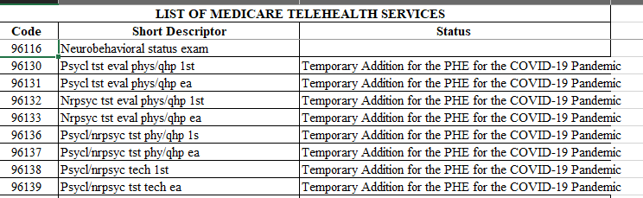

**Source:** <https://www.cms.gov/Medicare/Medicare-General-Information/Telehealth/Telehealth-Codes>

**Medicare/MedicaidLCD/NCD’s:**

<https://www.cms.gov/medicare-coverage-database/details/lcd-details.aspx?LCDId=33632&ContrId=275>

<https://www.cms.gov/medicare-coverage-database/details/lcd-details.aspx?LCDId=34646&ver=18&Date=&DocID=L34646&bc=iAAAABAAAAAA&>

**Emblem Health (HIP/GHI):** Only **96116**, **96160** and **96161** are covered under their temporary telehealth guidelines.

**Source:** <https://www.emblemhealth.com/content/dam/emblemhealth/pdfs/Supplemental%20Configuration%20for%20Telehealth%20Services%20for%20COVID%2019_04-03-2020.pdf>

**Empire BCBS:** Currently no neuropsychological code specific information is available for this plan. Per their bulletin, they cover telemedicine services for providers who have access to a video + audio platform:

*Empire covers telemedicine e.g., Live Health Online (live video audio) services for providers who have access to those platforms/capabilities and participate in the program.*

*Effective March 17, Empire began waiving member cost sharing for telemedicine (video + audio) visits, including covered visits for mental health or substance abuse disorders, for our fully insured employer plans, Individual plans, Medicare plans and Medicaid plans where permissible. Self-insured plan sponsors may opt out of this program. This will remain in place for 90 days.*

**Source:** <https://providernews.empireblue.com/article/information-from-empire-for-care-providers-about-covid-19>

**HealthCare Partners:**  Currently no CPT specific information available for this plan other than E&M services provided by physicians, NPs or PAs.

*“During this current state of emergency, patients should be treated through telehealth including telephonically where ever possible to avoid member congregation with potentially sick patients. Telehealth will be covered for all appropriate services for all patients appropriate to treat though this modality. However, telephonic services are only to be rendered for the care of established patients or the legal guardian of the established patient.*

*Telephonic evaluation and management services must be provided by a physician, nurse practitioner or physicians assistant, actively enrolled in the applicable governmental or commercial program.  As with any service, proper documentation in the patient’s medical record is required*.”

**Source:** <https://www.healthcarepartnersny.com/coronavirus-disease-covid-19-covered-telehealth-services/>

**Horizon BCBS:** Only **96116, 96156, 95158, 95159** and **96160** are currently covered under telemedicine.

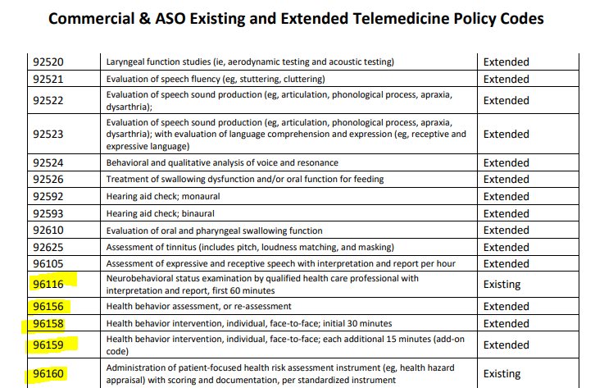

Source: <https://www.horizonblue.com/sites/default/files/2020-04/Commercial_Code_List.pdf>

**Multiplan:** No Information to be found

**Triwest Healthcare Alliance:** Per their update, all providers must have a *prior authorization on file* before providing telehealth services.

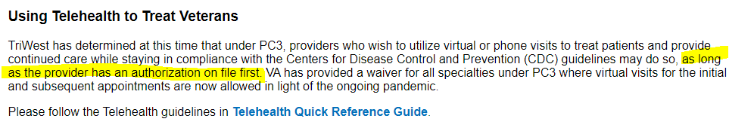

**Source:** <https://www.triwest.com/globalassets/vapc3-provider-files/quick-reference-guides/tele-health_qrg.pdf>

**United Healthcare, Oxford and UMR:**

*“UnitedHealthcare is allowing all codes on the*[***CMS Covered Telehealth Services list***](https://www.cms.gov/files/zip/covid-19-telehealth-services-phe.zip)*for this national emergency for Medicare Advantage, Medicaid*, and Individual and Group Market health plans.”*

**Source:** <https://www.uhcprovider.com/content/provider/en/viewer.html?file=https%3A%2F%2Fwww.uhcprovider.com%2Fcontent%2Fdam%2Fprovider%2Fdocs%2Fpublic%2Fpolicies%2Fcomm-reimbursement%2FCOMM-Telehealth-and-Telemedicine-Policy.pdf>